Medusa Hill Feast

Lin Xu

1. Basic

Genre – Simulation

Platform – Windows

Target Demographic – Audience targeted are in the range of age 13-32, in the North American and Asia regions. Aim to hook those who enjoys simulation games in order to relax, and enjoy collecting achievement.

Perspective – Top-down perspective.

1. Story

Player as a newcomer in Medusa Hill, will run a restaurant to start a new life, an meet folks in town, and practice skill.

* 1. Demo Plot

Arrive Medusa Hill, in the tavern of town, meet the owner of tavern whose name is Thais. Talk with Thais about want to own a restaurant, name it by the way. Thais will give first cooking quest to player, and give player basic guild go how to play and send gift to keep friendship and so on. She is the first friend of our game persona.

From there, player starts their life at Medusa Hill.

1. Characters
   1. Playable Character (Main Character)

|  |  |
| --- | --- |
| Name: | Jaaco/ Jaaca Moonmask (Temp Name, which is editable by player in the beginning) |
| Gender: | M/F (Choose by player in the beginning, have different past.) |
| Eye Colour: | Yellow |
| Hair Colour: | Light Blue |
| Job: | Restaurant Owner |
| Personality: | Quiet person, prefer doing instead of talking. Pessimism, was betrayed by blood relative, used like to run away to avoid things. However now his/her personality will be player’s choice. |
| Ability: | Jaaco and Jaaca has different hidden passive in combat, other ability will be shown in cooking system design or in fighting system design |

 Sample image, out combat figure v1.02

* 1. NPC

|  |  |
| --- | --- |
| Name: | Thais Riverborn |
| Job: | Tavern Owner |
| Description: | Friendly beautiful girl, calm, thoughtful and mature. Stingy, can be generous with somebody. Her tavern is the landmark of Medusa Hill; nobody knows why she would not give a proper name of her tavern. She will guild player through the tutorial. |

1. Level Design

In the project, there is only a plan of tutorial or demo. Player will know the basic of ingredient collecting and how to finish quest. If time allows, will also have the basic part of fighting system. Demo will take place in the tavern, and the demo would take 3-5 minutes.

1. Art

I will draw all the material by myself, the image quality depends on time frame. 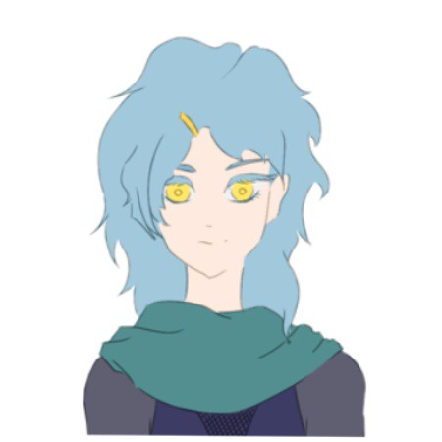[ Sample picture without lighting and shadow, dialog figure v1.01]

1. Sound & Music

I might write theme music by myself if time frame is widely enough. Will use open source sound effect probably. However, it would depend on time if I will create sound effect by myself too.

1. Gameplay

In the game, player will rent a restaurant and starts his/her business. Player has to pay 1000 moon coin as rent fee per month, or 700 sun coin to buy the estate. If failed to pay the rent, the game is over as a bad end, which is Jaaco/Jaaca leave the town alone, back to the battle field. In demo level, the requirement will be notified, but fail the game will be impossible.

In the game, currency has three units, star coin, moon coin, and sun coin. Currency can be used to buy ingredients, animals, weapons and etc. In the demo, Thais will show player how to pay rent and how to trade in market.

To cook, player has to cut or souse or whatever based on the cooking book. The cooking books’ size and price of dish depends on player’s cooking skills level.

The game will have a lot of achievement to unlock. In the demo, player will unlock the first achievement “Meet Thais”.

1. Game Control

|  |  |
| --- | --- |
| W  A S D | To move |
| Esc | To open menu |
| E | To interact |